# Docker Metrics

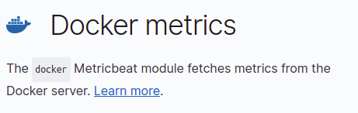

curl -L -O https://artifacts.elastic.co/downloads/beats/metricbeat/metricbeat-7.5.1-amd64.deb sudo dpkg -i metricbeat-7.5.1-amd64.deb

output.elasticsearch:

hosts: ["172.20.0.3:9200"]

username: "elastic"

password: "changeme"

setup.kibana:

host: "172.20.0.10:5601"

sudo metricbeat modules enable docker

sudo metricbeat setup

sudo service metricbeat start

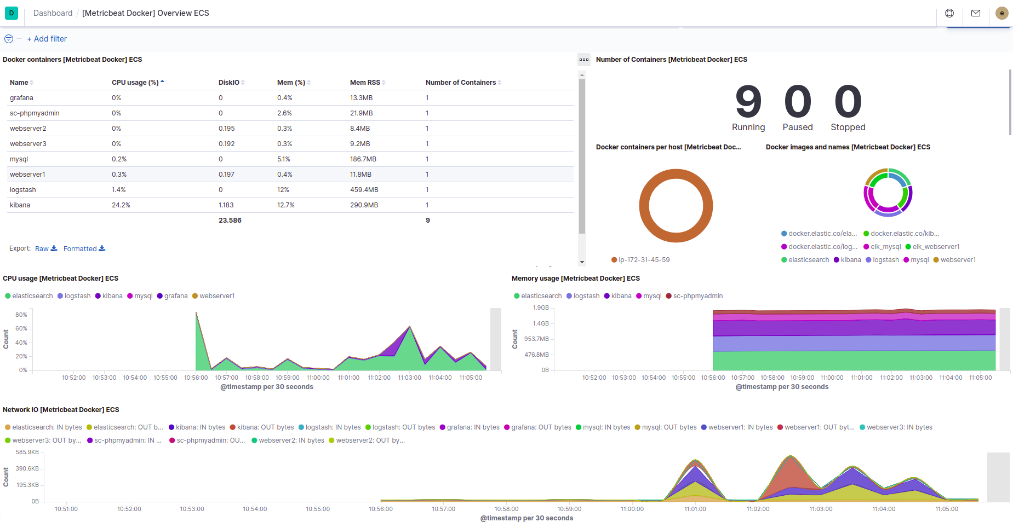

# System Metrics

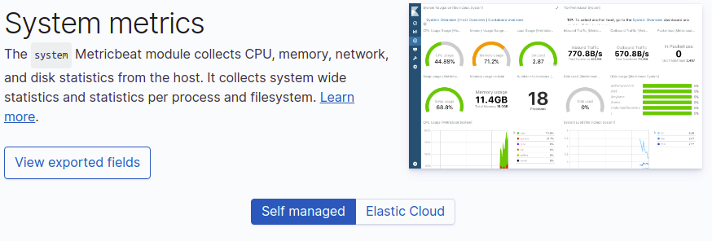

curl -L -O https://artifacts.elastic.co/downloads/beats/metricbeat/metricbeat-7.5.1-amd64.deb sudo dpkg -i metricbeat-7.5.1-amd64.deb

nano /etc/metricbeat/metricbeat.yml

output.elasticsearch:

hosts: [" elasticsearch:9200"]

username: "elastic"

password: "changeme"

setup.kibana:

host: "kibana:5601"

sudo metricbeat modules enable system

sudo metricbeat setup

sudo service metricbeat start

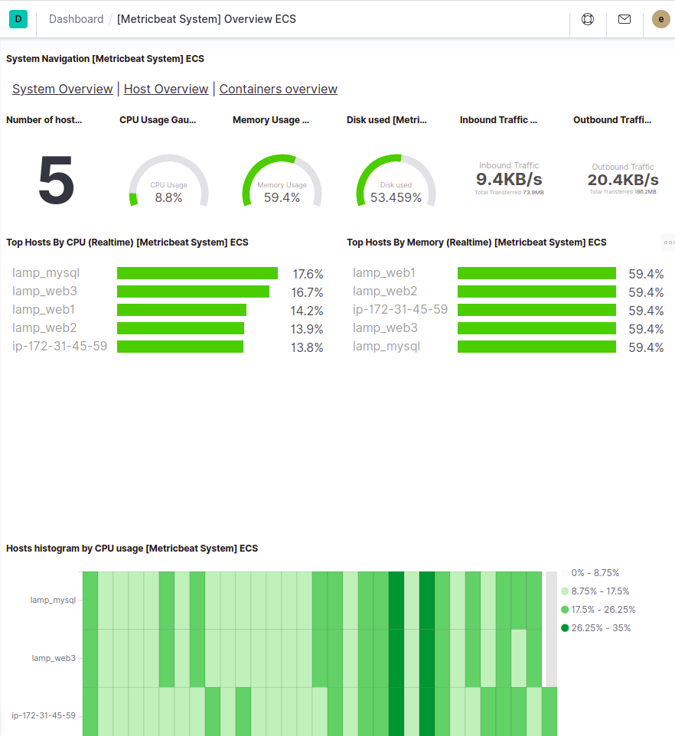

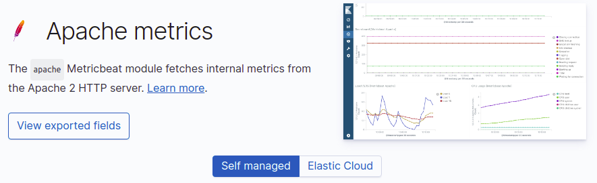

curl -L -O https://artifacts.elastic.co/downloads/beats/metricbeat/metricbeat-7.5.1-amd64.deb

dpkg -i metricbeat-7.5.1-amd64.deb

nano /etc/metricbeat/metricbeat.yml

output.elasticsearch:

hosts: [" elasticsearch:9200"]

username: "elastic"

password: "changeme"

setup.kibana:

host: "kibana:5601"

metricbeat modules enable apache

metricbeat setup

service metricbeat start

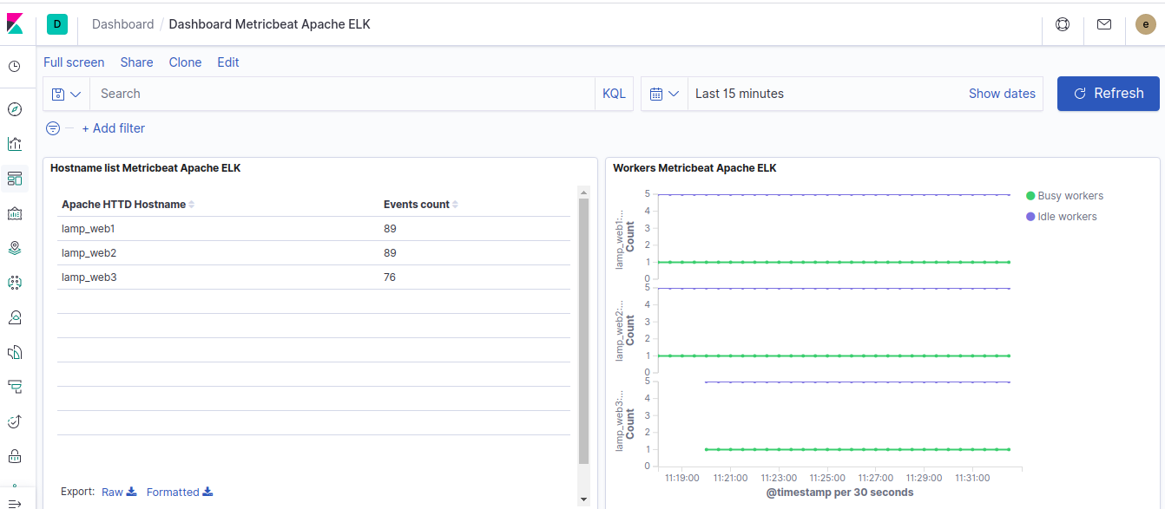

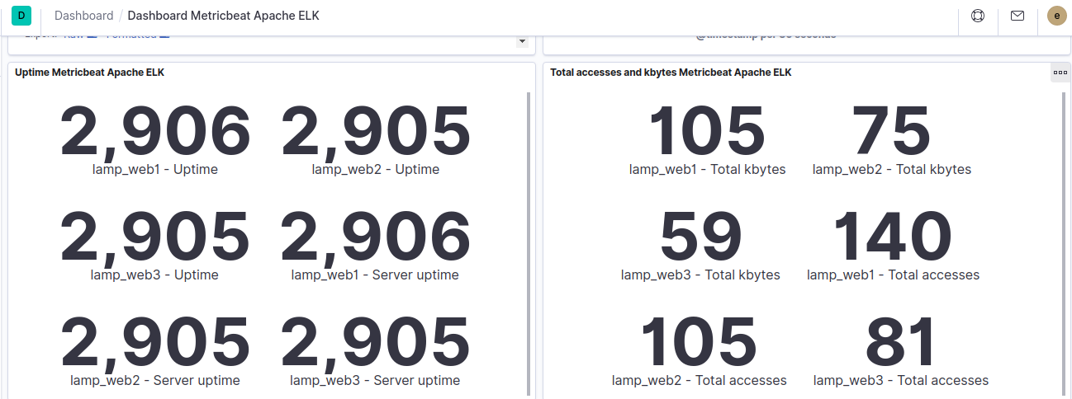

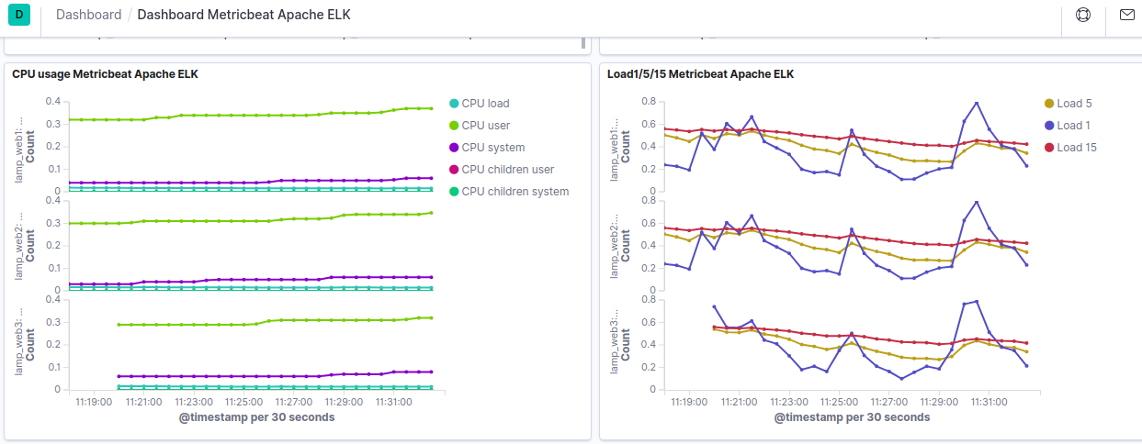

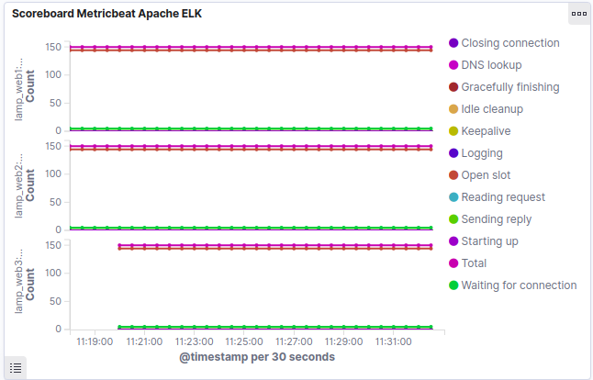

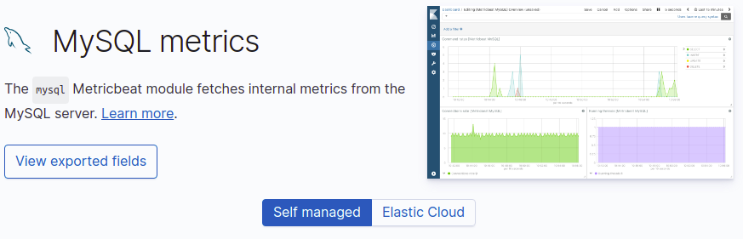

curl -L -O https://artifacts.elastic.co/downloads/beats/metricbeat/metricbeat-7.5.1-amd64.deb dpkg -i metricbeat-7.5.1-amd64.deb

nano /etc/metricbeat/metricbeat.yml

output.elasticsearch:

hosts: [" elasticsearch:9200"]

username: "elastic"

password: "changeme"

setup.kibana:

host: "kibana:5601"

metricbeat modules enable mysql

nano /etc/metricbeat/modules.d/mysql.yml

hosts: ["[root:tiger@tcp(127.0.0.1:3306)/](mailto:root:tiger@tcp(127.0.0.1:3306)/)"]

metricbeat setup

service metricbeat start

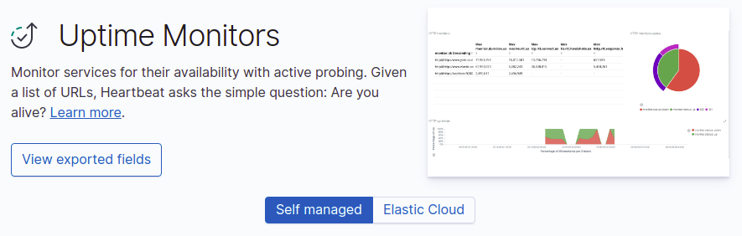

curl -L -O https://artifacts.elastic.co/downloads/beats/heartbeat/heartbeat-7.5.1-amd64.deb

dpkg -i heartbeat-7.5.1-amd64.deb

nano /etc/heartbeat/heartbeat.yml

output.elasticsearch:

hosts: [" elasticsearch:9200"]

username: "elastic"

password: "changeme"

setup.kibana:

host: "kibana:5601"

# Configure monitors inline

heartbeat.monitors:

- type: http

# List or urls to query

urls: ["<http://18.216.254.229:8001>"]

# Configure task schedule

schedule: '@every 10s'

heartbeat setup

service heartbeat-elastic start

